18. NFS (Network File System) Server

Tasks

1. Install the nfs-kernel-server package on your Linux VM and create a shared directory named /srv/music_share for sharing music files.

ANS:

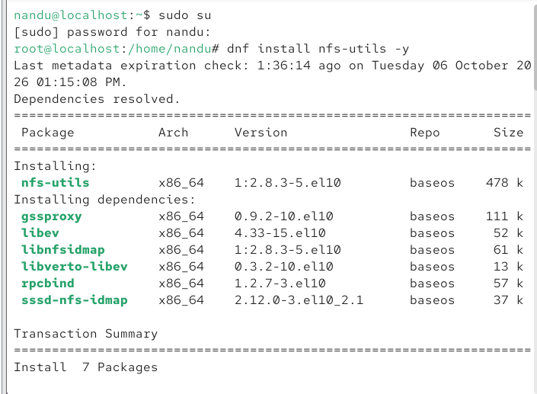

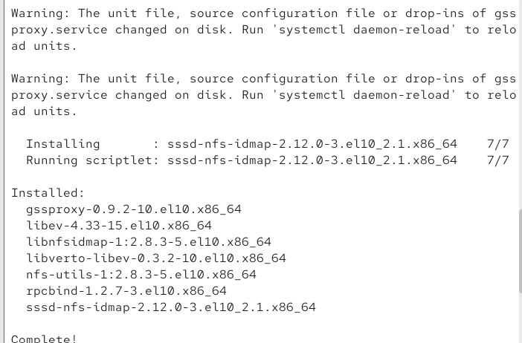

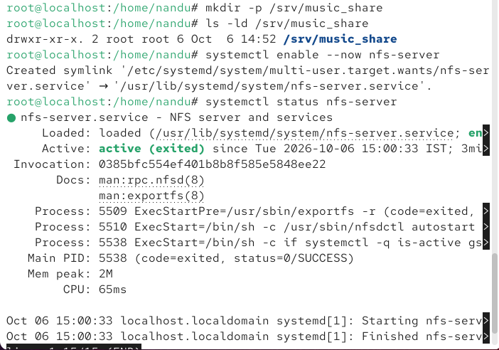

2. Configure /etc/exports to share /srv/music_share with read and write permissions to a specific client IP (use your own second VM or localhost for testing), then restart the NFS service.

ANS:

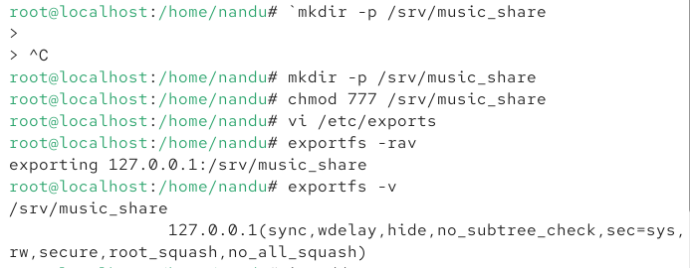

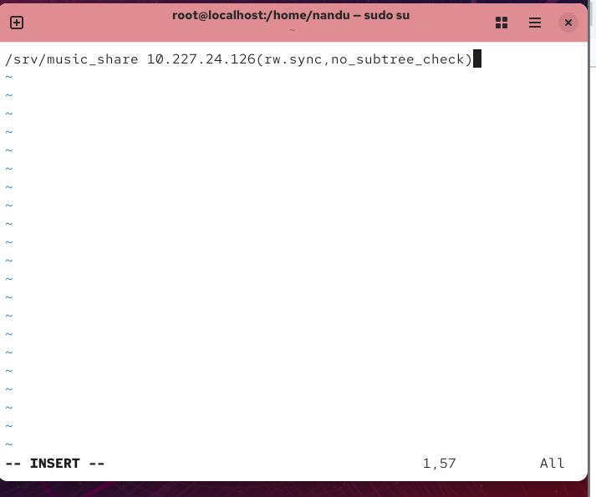

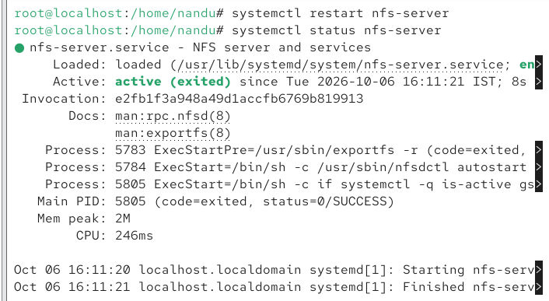

3. On a client machine, mount the NFS share from your server to a local directory named ~/mnt/playlist and verify you can create and access files in the shared folder.

ANS:
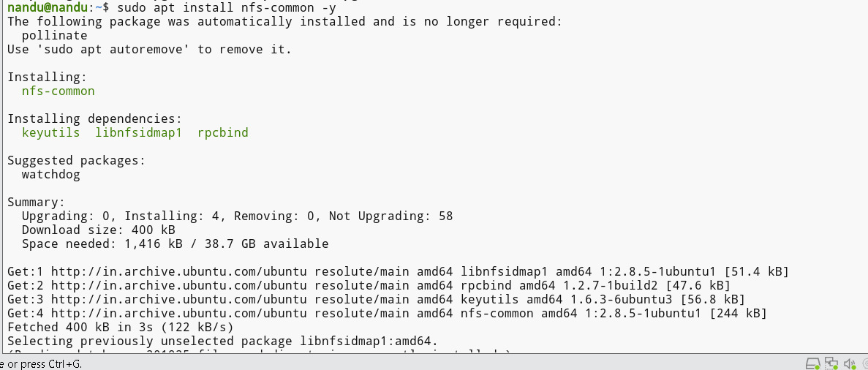

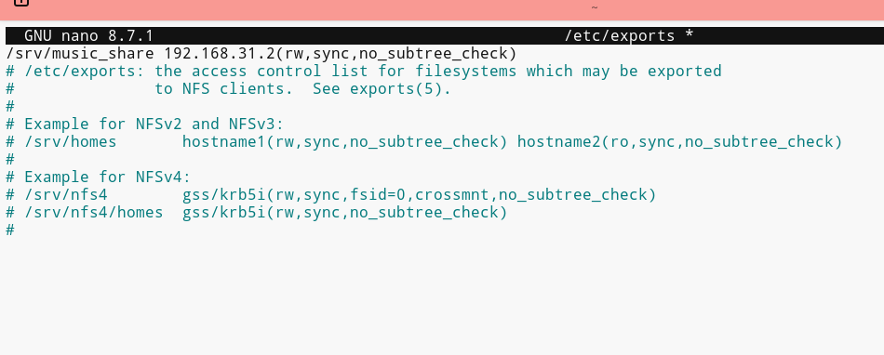

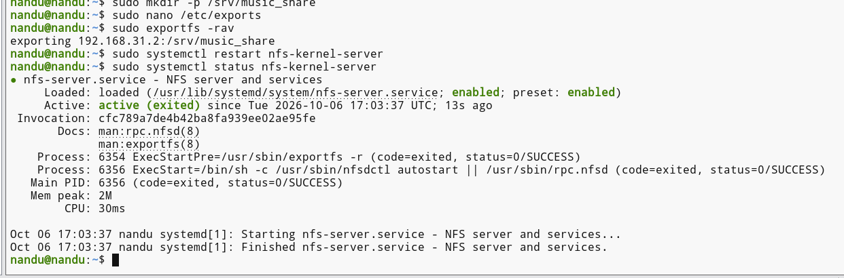

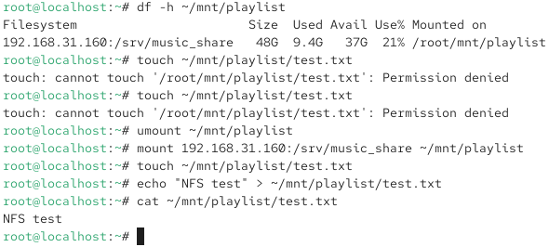

4. Simulate a Zomato-style shared menu folder: add a subfolder called 'restaurant_menus' inside your NFS share, copy any 2 PDF or image files into it, and confirm they are visible from the client mount.

ANS:

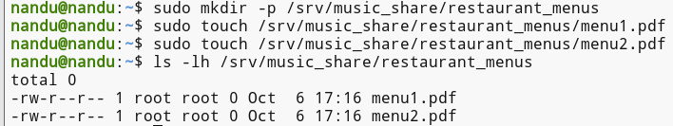

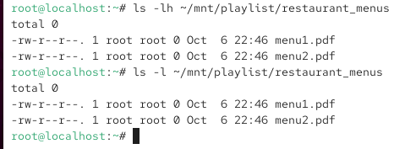

5. Un-mount the NFS share from the client and update your /etc/exports file to restrict access to read-only, then remount and test that you cannot create or modify files in the shared folder. Use the 'ro' option in /etc/exports for read-only access.

ANS:

